Extracting IPA from iPhone

Hi fellows. Many of you are looking for how to fetch/extract IPA file from iPhone. Like in android mobile/emulator it is very easy and more of a drag and drop to extract APK. But in iPhone it is a bit tricky. I will try to make it as simple and easy as it can be. So be bear with me and let’s do this.

Note: Device should be Jailbroken, if you guys want to jailbreak the device. Read my blog at this link:

[Muhammad Shoaib on LinkedIn: Jailbreaking iOS 15 to 16: A Step-by-Step Guide](https://www.linkedin.com/posts/markhor_jailbreaking-ios-15-to-16-a-step-by-step-activity-7087348939162607616-nH0D?utm_source=share&utm_medium=member_ios)

Step 1: Download the necessary files

* 1. Download this All-in-one iDevice tool from this link; <http://www.3u.com/>

Step 2: After the installation of 3u tool

2.1: Run the tool and you will be asked to connect your device to Laptop

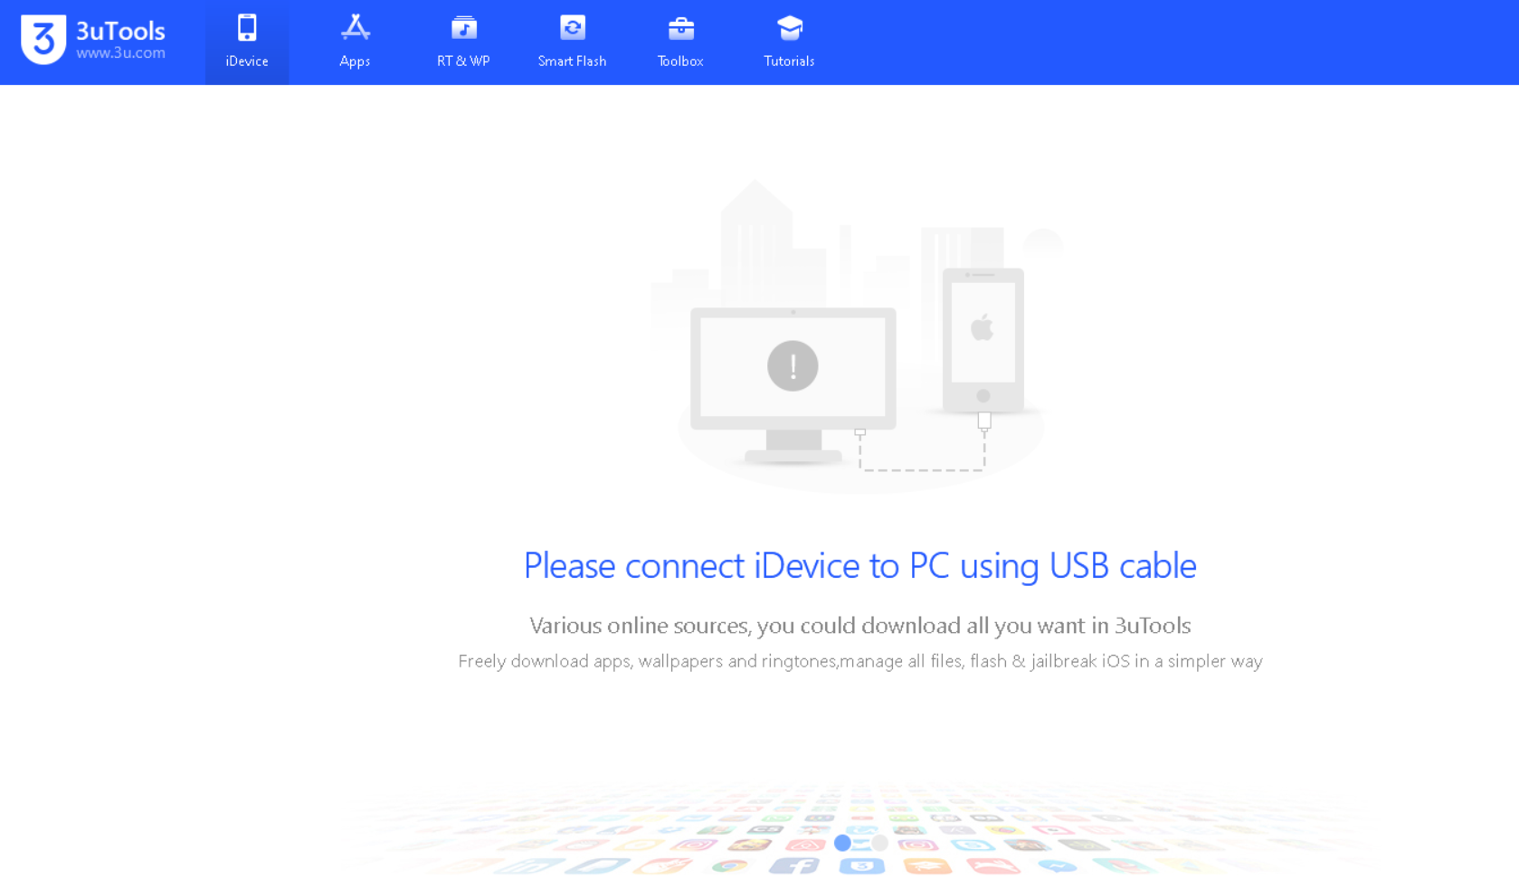

Figure 1

2.2: Connect your device with cable and your device will prompt ‘Trust this computer’

2.3: After trusting the computer following screen will appear on your 3uTools

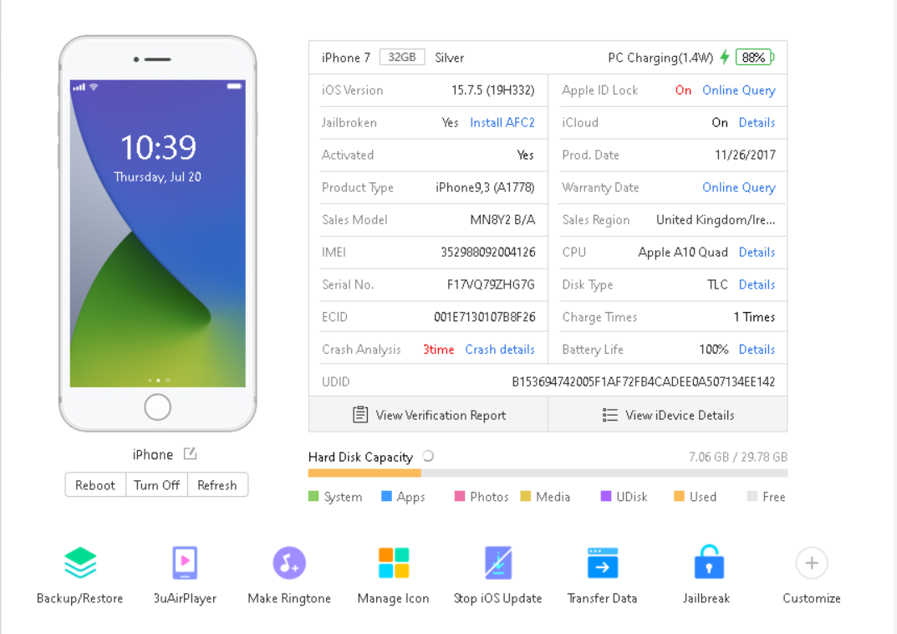

Figure 2

2.4: Select the Toolbox Option

2.5: Select Open SSH Tunnel from More tools Option as can be seen in the figure below:

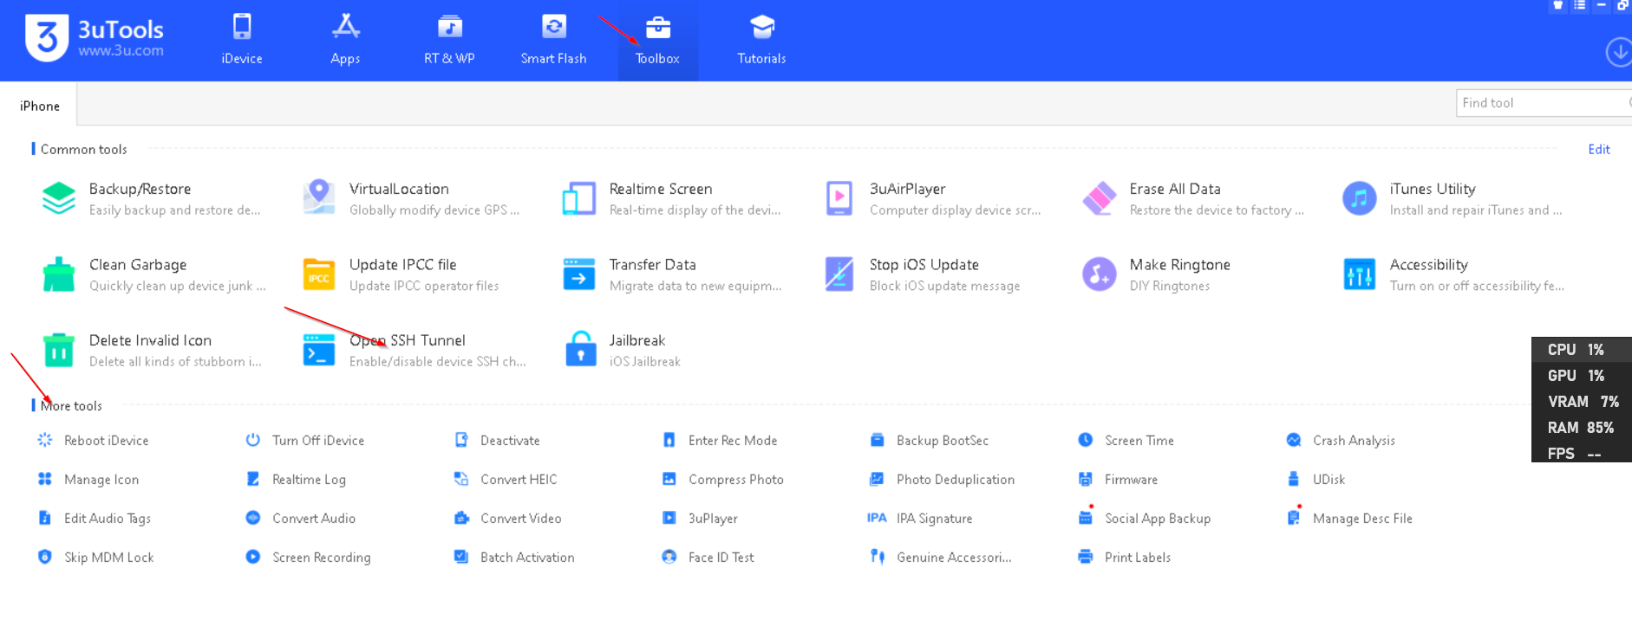

Figure 3

*Note: For me it is in the first field because I have added it to my shortcut list.*

2.6: After clicking Open SSH Tunnel following screen will prompt:

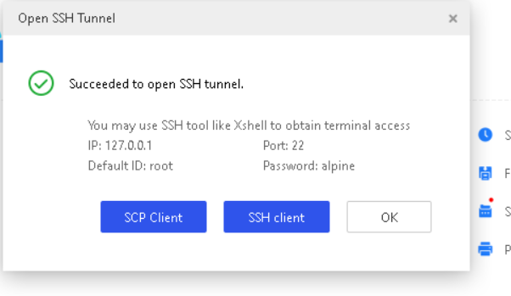

Figure 4

2.7: Select SSH Client and you will be redirected to putty connecting iPhone

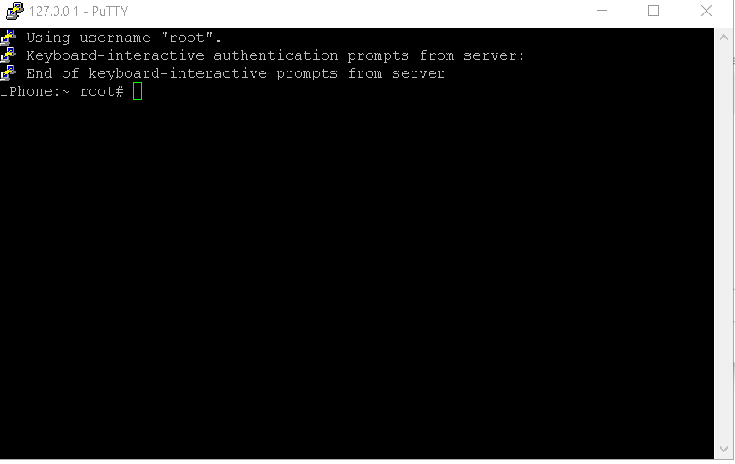

Figure 5

2.8: Now navigate to /var/container/Bundle/Application by using cd command

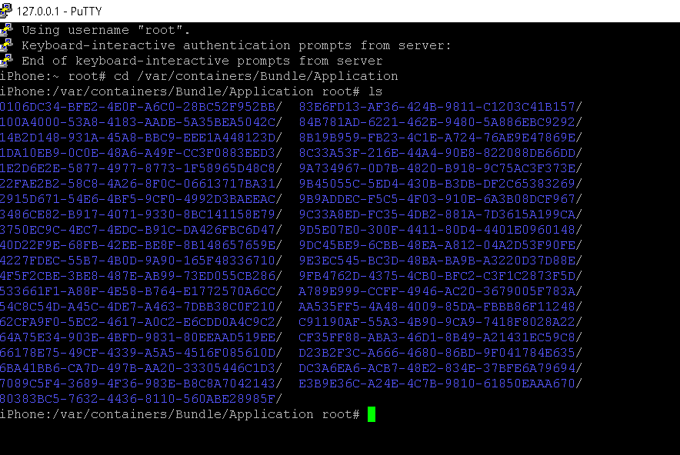

Figure 6 These are application installed in the iPhone

2.9: Now we have to choose the Application which we want to extract from local storage of the phone. For this show case, we will be choosing any of the app. Let navigate to the folder of app

Step 3: Copy and Zip the App

3.1: By using ‘cd’ command navigate the selected App folder

3.2: By using ‘mkdir’ command make the new folder with any desired name like in our case ‘extract’

3.3: Use the ‘ls’ command to list down the files/folders

3.4: Now you can see the your ‘extract’ folder is created.

3.5: Use ‘cp’ command to copy and paste the target.app folder to our ‘extract’ folder

3.6: Now target.app is copied in the ‘extract’ folder

3.7: Use ‘zip -r’ command to zip the ‘extract’ folder to /var/root/



Figure 7

*Note: it will take less then minute to zip the file and copy it to /var/root path.*

3.8: To make sure every work we have done is in order, we have to navigate to the /var/root path to check our extracted file is there??



Figure 8

You can see the News.ipa file is present in the mentioned path. Now lets download it to our Laptop

Step 4: Download the IPA in Laptop

4.1: Open the 3uTools and select Open SSH Tunnel > SCP Client

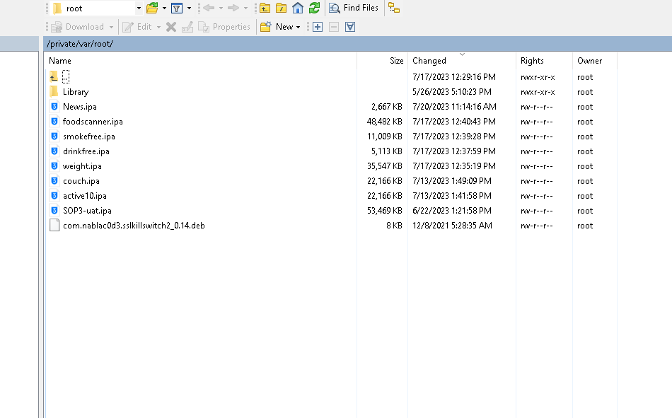

Figure 9 Navigate to the /var/root/ path to check the file

4.2: Now right click on the App> Download> Select the Directory where you want it to be saved.

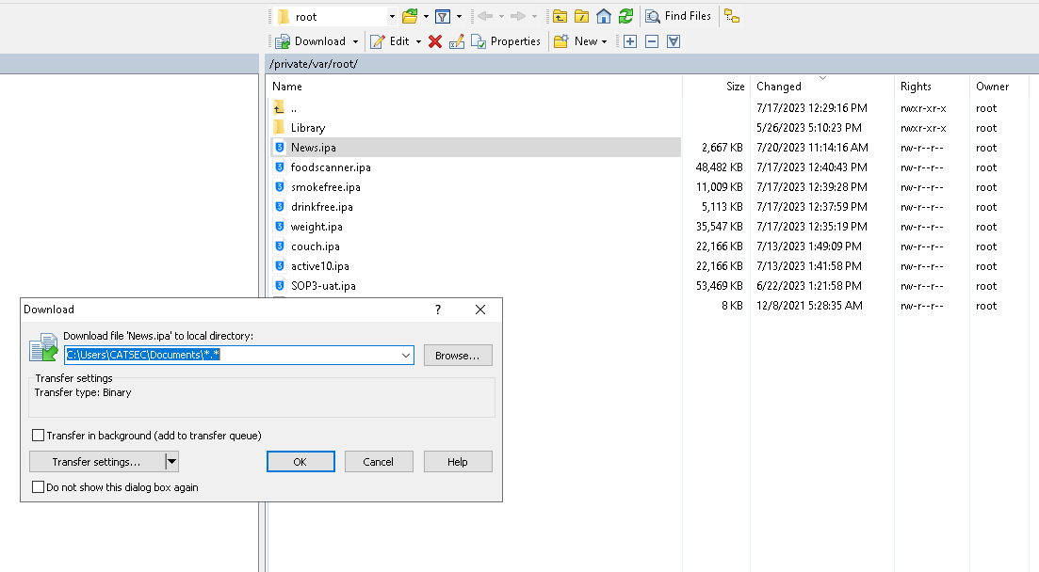

Figure 10

Hurray!!!!!!!!!!!!!! your file is downloaded to your laptop.

**Please do follow me on my linkedin.com/in/markhor**

**My next article will be on How to Install SSL Kill Switch on iOS 15 to 16 version. **